Bodymapping Collection/
2009-2010

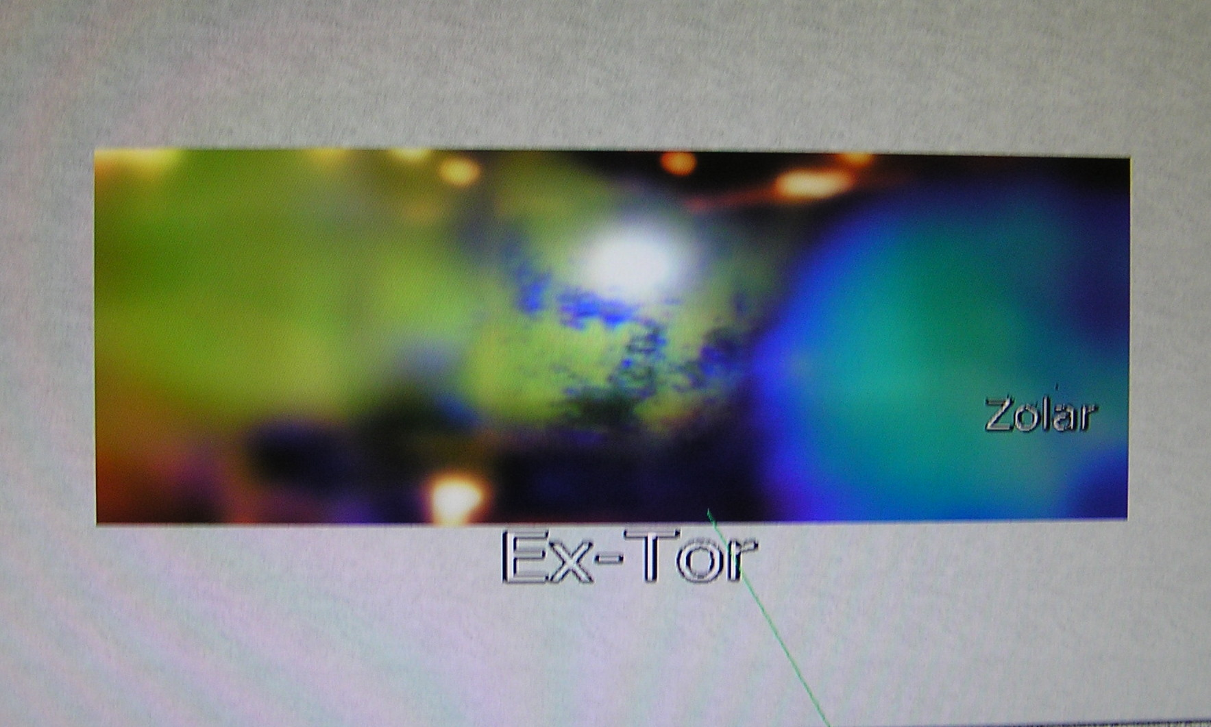
MLM screen-Quantum bubbles-X-Quanta
1
- MLM Screen-Quantumbubbles-X-Quanta 
- Virtual supra-system
- Quantum figurants
- Expanded fields

http://www.everyoneweb.es/myriamsolar
http://www.youtube.com/watch?v=_RGhQ9sTn1g
http://maps.google.com/maps/ms?ie=UTF8&hl=es&msa=0&msid=118210084351813051367.000467737e6eb054dcfa3&ll=-11.523088,-65.478516&spn=54.873792,67.587891&z=4
http://www.youtube.com/watch?v=ugTr_Jwx4-w
http://myriamsolar.blogspot.com

MLM Screen-Quantumbubbles-X-Quanta

Body mapping Collection reconstructs with the serie MLM Screen- Quantum Bubbles-X-Quanta a new context of ephemeral actions for the planetary network that began with the projection of ExMuerte + Invitadoenlugarkuantico ExTor in format web-art in 1997. The piece was selected for Electronic Arco in the same year and continued with Performance of the Bio-Organisms in 2007 in the Canal Isabel II, Bio-Organisms & Intelligent Autonomous Universes in 2008: http://ca.youtube.com/ivettesolar and now is relaunched with the expanded project MLM Screen- Quantum Bubbles-X-Quanta in multiform spaces that include Youtube Channehttp://www.youtube.com/watch?v=_RGhQ9sTn1gl, http://www.youtube.com/watch?v=ugTr_Jwx4-w, Google Maps http://maps.google.com/maps/ms?ie=UTF8&hl=es&msa=0&msid= 118210084351813051367.000467737e6eb054dcfa3&ll=-11.523088,-65.478516&spn=54.873792,67.587891&z=4, Google Gallery 3D http://sketchup.google.com/3dwarehouse/search?styp=c&viewer=06046494972893389522&scoring=m, Google Earth, Complexity Gallery
http:// www.everyoneweb.es/myriamsolar, other international spaces and the blog http://myriamsolar.blogspot.com that will report on the collection and the route of the tour.
Its singularity resides in which the ephemeral actions of the virtual figurants, and their identity, are binding with places of the Land since where they will be projected in a counterpoint of two perspectives work in progress through photographs, videos and modelling shapes.

Virtual Supra-system

The thesis of the serie is that these images are created for a strange combination and entangled of states in which there are superimpositions, transfers or projections from a sequence close to the processes of the quantum teleportation.
Their materialization requires of the potential configuration of a collaborative system with rank of supra-system, capable to reconstruct a corporal replica of someone inmnaterial and invisible with all its information in the S-T.

Quantum figurants

When the not visible body achieves this representation appears the registration of the quantum figurant that emerges with identity, personality and specific ways, being able to carry out an ephemeral action in the unique suitable setting that is Internet.
Its action unfolds a vocabulary of gesture, pose and movement, determining the format of the event that adopts that of frozen or fixed image and in movement. The resultant performance will be an ephemeral action of autonomous bodies with fields of power that speak since a multidisciplinary cluster with energy and vitality, of spontaneous and indeterminate form, instructive and provocative.

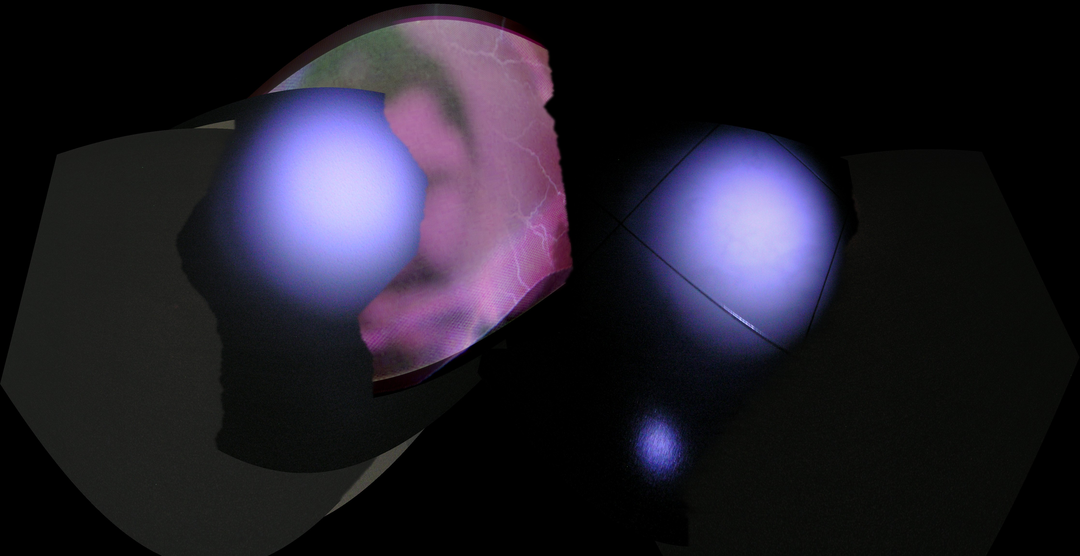

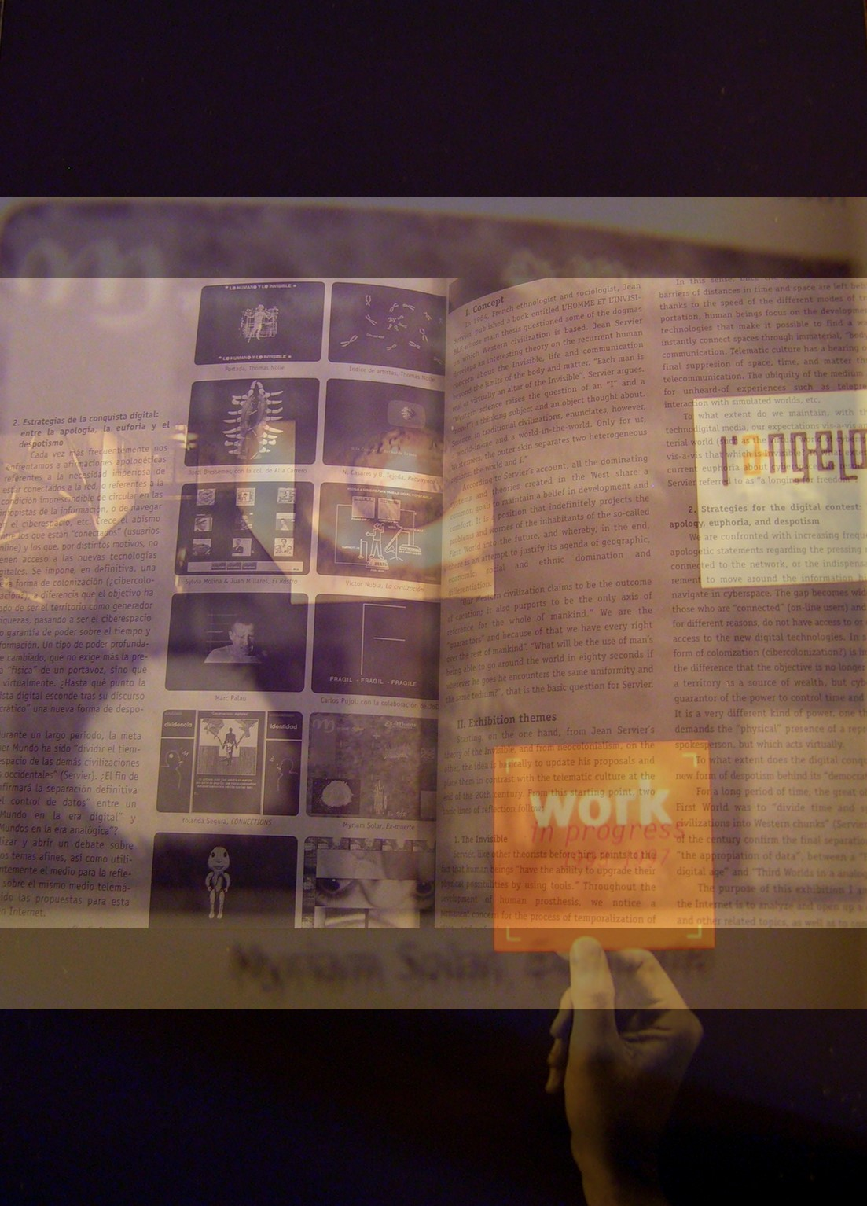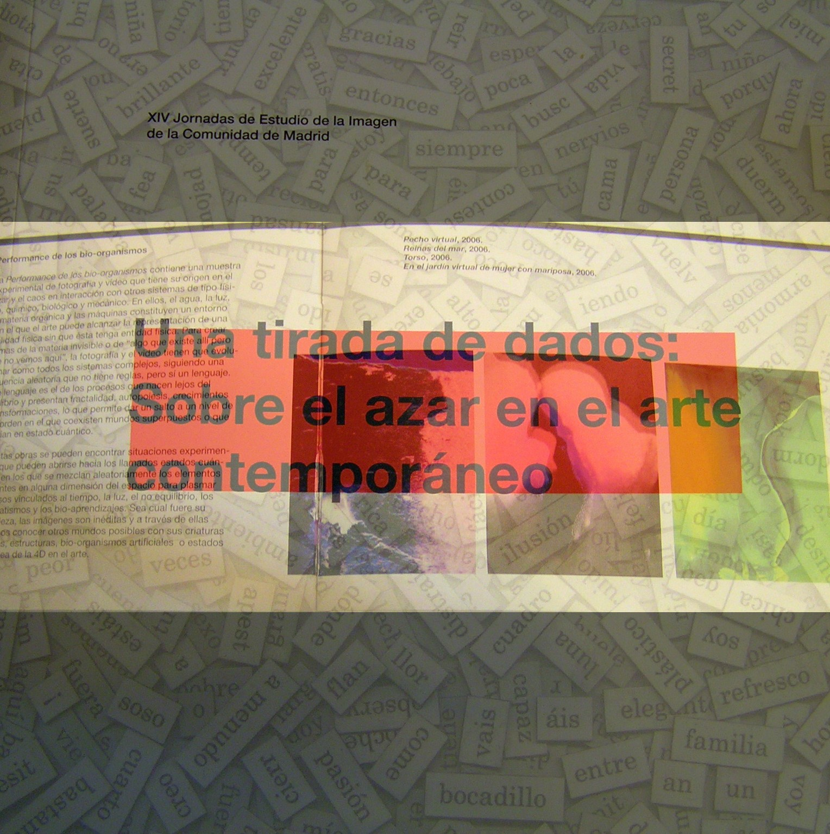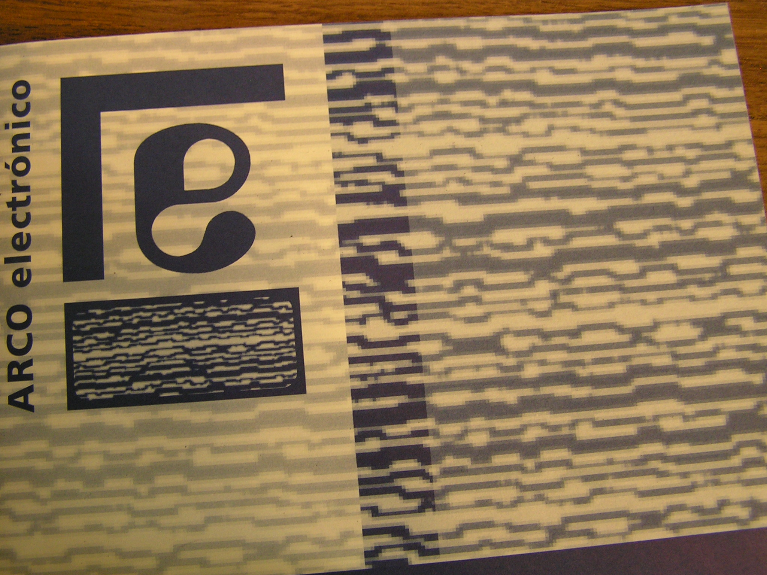

Expanded fields

The nucleus of investigation and artistic expression of the Body mapping gets into focus in the emergency of the body projected-expanded-transfered of a techno-bio-organism in which underlies an identity construction process of the image that could to be seen from the absence or presence, from of the material or of the quantum teleportation, conforming the new territory of sense and identification proposed by the artist.
The artwork is converted thus in a field of energy and experience, capable to change the perception of the spectator on its physical reality, the conventional values of the art, the life and what there is beyond in the empty cosmic one.

